Service Specification AND VARIATION

Community Pharmacy local commissioned service

1st April 2021 – 31st March 2023
Public Health – Stop Smoking Service

VARIATION
STOP SMOKING SERVICES IN COMMUNITY PHARMACY SETTINGS
Service Specification | For the provision of a Community Pharmacy  Locally Commissioned Service
Service | Community Pharmacy Stop Smoking Service
Commissioner Lead | Jimmy Burke - Health Improvement and Tobacco Control Programme Manager  Becky Woodiwiss – Public Health Principal
Period | 1st April 2021 – 31st March 2022
Date of this variation | 6th April 2021

1. Summary
This variation provides an addendum to the existing Stop Smoking Services in Community Pharmacy Settings Specification 1st April 2020 – 31st March 2021, now updated to cover the period 1st April 2021 – 31st March 2023, which follows. It details variations in service requirements and contractual terms and conditions for the Stop Smoking Services in Community Pharmacy Locally Commissioned Service.
These changes are being implemented in response to the national COVID-19 lockdown requirements, which have implication for normal service provision. Evidence tells us that COVID-19 presents some greater risks to people who smoke and so it is crucial that stop smoking services continue to be offered, albeit that support must be offered only in an appropriately risk-managed way. This may mean that smoking cessation support will be delivered remotely via telephone or online video-conferencing platforms as well as face-to-face with appropriate infection control protections.
This variation should be read in conjunction with and in addition to the Stop Smoking Services in Community Pharmacy Settings Specification 1st April 2021 – 31st March 2023, which follows. This variation has precedence.
The provisions in this variation apply only for the period 1st April 2021 – 31st March 2022 (12 months) and a review will take place at that time to ascertain if circumstances relating to the COVID-19 pandemic necessitate a further contract variation.

2. Changes to service model encompassed in this variation
2.1 Stop smoking advisors are expected to take an initial carbon monoxide (CO) reading at the initial assessment appointment but only if it is assessed as safe to do so. Providers should carry out a risk assessment (or review their existing risk assessments) to ascertain whether this step is sufficiently safe to undertake. Where it is assessed as not sufficiently safe, this step can be omitted and the clients’ self-reported smoking status shall suffice.
2.2 CO readings are normally required to be taken at weekly appointments. However, this requirement is subject to the same risk assessment, professional judgement and individual discretion of the provider’s stop smoking advisors. CO readings may be omitted where the process is judged unsafe.
2.3 A final CO reading to confirm quit status at 4 weeks is normally required. Once again, following an appropriate risk assessment, if the provider assesses CO monitoring as not sufficiently safe, this step can be omitted, and the clients’ self-reported smoking status shall suffice. However, as per the payment schedule, only CO validated 4-week quits will attract the higher quit payment of £70. The payment for a non-CO verified quit remains £20.

3. Service Targets and Quality Indicators
Community Pharmacies signing up to deliver the stop smoking service must adhere to the service targets as detailed in the Stop Smoking Services in Community Pharmacy Settings Specification 1st April 2021 – 31st March 2023, which follows, with the following change:
3.1 Providers no longer need to ensure that 85% of four week quits are CO validated.

4. Service Payments
Payment arrangements will be as detailed in Stop Smoking Services in Community Pharmacy Settings Specification 1st April 2021 – 31st March 2023, which follows, with the following change:
4.1 Payments for attendance of training events will still be paid as per existing terms, however, the delivery of training will be adapted to ensure appropriate physical distancing and/or infection control is maintained – see section 6 below.

5. Service Standards and Guidance
The stop smoking service will be delivered in line with the most recent evidence based practice recommendations for stop smoking services issued by the National Institute for Health and Care Excellence (NICE: NG92 / PH14), National Centre for Smoking Cessation and Training (NCSCT) guidance and Local Stop Smoking Services: Service and delivery guidance 2014 published by PHE. In addition:
5.1 Where remote consultations are delivered, the service should be delivered in line with the most recent National Centre for Smoking Cessation and Training (NCSCT) guidance: Remote consultations: Delivering behavioural support and supply of NRT, March 2020 (https://www.ncsct.co.uk/usr/pub/Remote%20consultations.pdf).

6. Accredited Training
Training, professional development and update meeting requirements are as detailed in the Stop Smoking Services in Community Pharmacy Settings Specification 1st April 2021 – 31st March 2023, which follows, with the following amendments:
6.1 The two-day face-to-face course provided by the BSUH Stop Smoking Lead will be replaced by a shorter, appropriate remotely provided solution. This training solution will encompass the same content as the training previously provided but will be delivered in a safe way e.g. via an online video-conferencing platform. Participation in both parts of the training will continue to be mandatory.
6.2 Registered advisors will continue to be expected to maintain continuing professional development by participating in a minimum of one CPD/network session annually (delivered Quarterly by the Healthy Lifestyles Team Stop Smoking Lead at BSUH).

7. Service Promotion
Additionally, providers will be expected to promote and participate in local and national smoking cessation campaigns to promote the uptake of local stop smoking services among members of the public who smoke.

Appendix 9
Providers may continue to provide the domiciliary service, as detailed in appendix 9 of the Stop Smoking Services in Community Pharmacy Settings Specification 1st April 2021 – 31st March 2023, which follows, but only if it is formally assessed as safe to do so. Providers will carry out a risk assessment (or review their existing risk assessments) to ascertain whether this service is sufficiently safe to provide. Where it is assessed as not sufficiently safe, the service will not be provided. Telephone and video appointments may be a suitable alternative, with arrangements made for delivery of pharmacotherapies. Once again, the provision of a domiciliary service is subject to the same risk assessment, professional judgement and individual discretion of the provider’s stop smoking advisors.

END OF VARIATION.

SERVICE SPECIFICATION
STOP SMOKING SERVICES IN COMMUNITY PHARMACY SETTINGS
1st April 2021 – 31st March 2023

Service Specification | For the provision of a Stop Smoking Locally Commissioned Service
Service | Community Pharmacy Stop Smoking Service
Commissioner Lead | Rebecca Robb - Public Health Tobacco control and Healthy Lifestyles Manager
Period | 1st April 2021 – 31st March 2023
Date of Review | March 2023

The Community Pharmacy Stop Smoking Service Specification is applicable as the overarching specification to provide stop smoking services in the community pharmacy setting. The following additional Community Pharmacy Stop Smoking Specifications must be delivered according to the service descriptions and objectives defined in this document.

The Community Pharmacy Domiciliary Stop Smoking Service
The Community Pharmacy Young Persons Stop Smoking Service
The Community Pharmacy Nicotine Replacement Therapy Voucher Scheme
The Community Pharmacy Provision of Varenicline on Patient Group Direction

Community Pharmacies signing up to provide Stop Smoking services must indicate on the sign-up sheet provided by Public Health which elements of the service they intend to provide.

Introduction

Locally commissioned stop-smoking services continue to offer the best opportunities for individuals to make a quit attempt. This service specification is intended to support the residents of Brighton and Hove to stop smoking and applies to the provision of a locally commissioned stop smoking service within a community pharmacy setting. The focus of the service is to offer one to one behavioural support and advice to people who want to give up smoking including the supply of appropriate stop smoking pharmacotherapy.

Background

The UK is a world-leader in tobacco control, but smoking remains the leading cause of preventable illness and premature deaths in England. It is one of the most significant factors that affect health inequalities and the biggest contributor to ill health, particularly cancer, coronary heart disease and respiratory disease. Reducing smoking prevalence therefore remains a key public health priority and a national focus.

National trends show that overall prevalence of tobacco smoking has declined since 2004, from 19% in 2014 to 14.9% in 2017, however in contrast, rates amongst vulnerable population groups have not fallen and this remains a priority target area for Brighton and City Hove Council (BHCC). At a rate of 18% for adult prevalence (APS, 2017), there are around 42,630 smokers in Brighton & Hove, this is significantly higher when compared to the South East (13.7%) and England average (14.9%). Priority sub groups for service targeting in BHCC include individuals from, routine and manual occupations, Black Asian Minority Ethnics (BAME), Lesbian, Gay, Bisexual, Trans and Queer (LGBTQ) and people under the age of 25 years.

Smoking is more prevalent in areas of the city with higher levels of deprivation. General Practitioner (GP) cluster statistics for smoking prevalence show that both the upper centre and east of the city are most impacted and would benefit from targeted support. See Table 1 below.

Table 1: Smoking Prevalence Rate for GP Clusters by Area- 2018’
Cluster by Area | Current smoking prevalence rate
Cluster 1 East | 32.6%
Cluster 5 Centre & North East | 27.5%
Cluster 2 Centre & East | 27.1%
Cluster 4 West | 25.7%
Cluster 3 North | 24.2%
Cluster 6 West & North | 24.0%

Table 2: Map showing the Brighton and Hove GP Cluster Areas
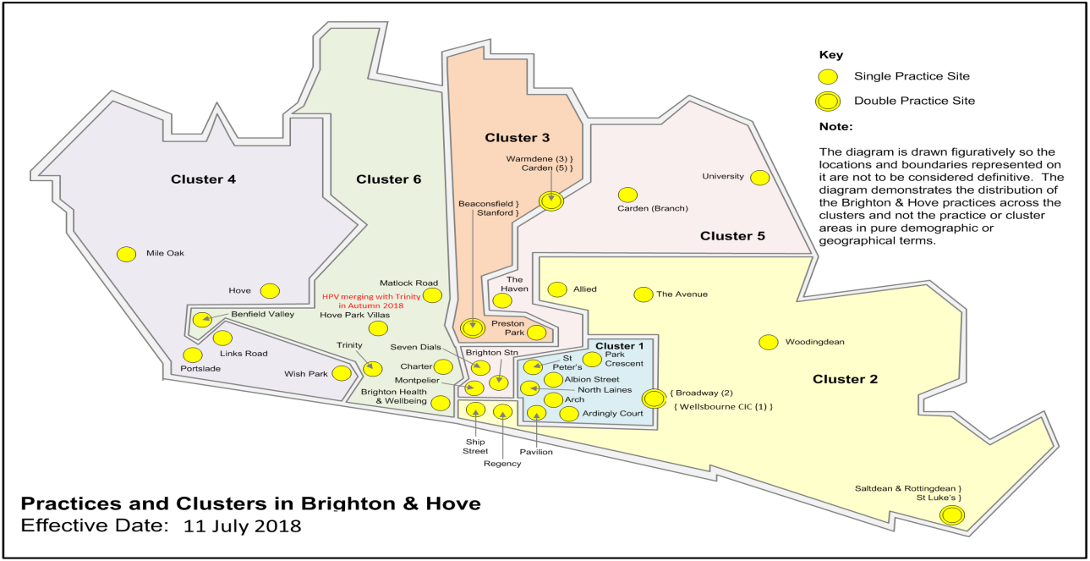

In addition, BHCC has commissioned a Hospital Stop Smoking Lead (HSSL) based at the Brighton Sussex University Hospital (BSUH). The post supports inpatients, outpatients and all BSUH staff to stop smoking. The role is also commissioned to provide the BHCC Stop Smoking Training Programme and stop smoking update meetings for community pharmacy teams.

Ambitions set by the Department of Health, in the tobacco control plan, ‘Towards a smoke-free generation: a tobacco control plan for England’ have four specific smoking-related outcomes to achieve by the end of 2022:

- Reduce smoking among adults in England from 15.5% to 12% or less
- Reduce the inequality gap in smoking prevalence, between those in routine and manual occupations and the general population
- Reduce the number of 15 year olds who regularly smoke from 8% to 3% or less
- Reduce the prevalence of smoking in pregnancy from 10.5% to 6% or less

1. Service Outline

- This service specification applies to the provision of stop smoking services within the community pharmacy setting. The focus of the service is to offer one to one behavioural support and advice to people who want to give up smoking including the supply of appropriate stop smoking pharmacotherapy.
- The service will be commissioned in line with the most recent evidence based recommendations for stop smoking services issued by the National Institute for Health and Care Excellence (NICE: NG92 / PH14), National Centre for Smoking Cessation and Training (NCSCT) guidance and Local Stop Smoking Services: Service and delivery guidance 2014 published by Public Health England (PHE).
- The service will help to increase choice and support individuals from identified sub-groups with high prevalence tobacco use, such as routine and manual occupations, Lesbian, Gay, Bi-sexual, Trans and Queer (LGBTQ), Black, Asian Minority Ethnics (BAME) and individuals under the age of 25.

- The service will be provided by Stop Smoking Advisors (SSA) in accordance with the training requirements of BHCC. A minimum of two trained Stop Smoking Advisors (SSA) are required to complete the training within six months of starting to offer the service. A disclosure barring service (DBS) check must be in place for all staff providing the service.
- The SSAs will help facilitate access to, and supply appropriate stop smoking pharmacotherapy. The pharmacy can provide up to 12 weeks of nicotine replacement therapy (NRT) or Varenicline tablets. Varenicline can only be supplied on Patient Group Direction (PGD) by authorised pharmacists who have enrolled to provide the service on PharmOutcomes (refer to the Community Pharmacy Provision of Varenicline under PGD service specification). Individuals requesting Bupropion as a stop smoking pharmacotherapy should be referred to their GP.
- Information collected from individuals using the service must be recorded on PharmOutcomes. PharmOutcomes records (non- identifiable patient data) will be used for audit and evaluation purposes .The templates also includes the information required for the Gold Standard Monitoring Form. This standard monitoring form provides the quarterly data required by stop smoking services for submission to the Health and Social Care Information Centre (HSCIC).
- The Service is remunerated quarterly when PharmOutcomes data is submitted. Data must be submitted before the 14th of the following month.

2. Service Objectives

- To provide a high quality, accessible and comprehensive stop smoking service across the city, delivered by trained (Disclosure and Barring Service (DBS) checked) Stop Smoking Advisors.
- To support the Government’s Tobacco Plan (published March 2018) to reduce prevalence by 2022.
- To have a sufficient number of suitably qualified and skilled staff available (minimum of 2 trained Stop smoking advisors per pharmacy) within 6 months of starting the contract. SSAs are trained to provide individuals with informed choices on the following quit methods: Dual NRT, Varenicline on PGD, electronic cigarette (Vape friendly IBVTA registered) and behaviour change support. See Appendix 5 for latest guidance on electronic cigarettes (e-cigarettes) and vaping.
- To ensure that robust data is collected using Pharmoutcomes in order to measure the outcomes and effectiveness of the service.
- To refer all individuals that have not maintained a 4 week quit or have relapsed into other stop smoking services, such as Health Trainers (for 18+). Refer to the Community Pharmacy Young Persons Stop Smoking Service Specification (Appendix 11) for details on the provision of services to individuals under the age of 16.
- To refer housebound Individuals unable to access the stop smoking services to pharmacies commissioned to provide the Community Pharmacy Domiciliary Stop Smoking Service – see Appendix 9
- To refer young people under the age of 16 years to pharmacies meeting the YPSS service standards to provide the Community Pharmacy Young Persons Stop Smoking Service- see Appendix 11.
- The stop smoking service should be promoted by the whole team and pharmacies should participate in annual health promotion campaigns such as National No smoking Day, World No Tobacco Day and Stoptober.

3. Service Standards

- Individuals aged 16 years and over are eligible to engage with the SS service. Young people under the age of 16 years should be referred to pharmacies meeting the service standards to provide the Young Persons SS service.
- Individuals not sufficiently motivated to quit or who prefer to access another stop smoking service should be referred to Health Trainer’s Service. Individuals can be referred by following the information on the link below: https://www.brighton-hove.gov.uk/content/health/your-healthy-lifestyle/make-a-healthy-lifestyles-referral
- Individuals with severe cardiovascular disease e.g. myocardial infarction with a history of recent cerebrovascular disease e.g. stroke should be referred to their GP for stop smoking advice. .
- All pharmacies signed up to the specification are to also dispense NRT products to an individual referred into service from Health Trainers of Sussex Partnership Foundation Trust (SPFT) under the NRT voucher scheme.
- Individuals who do not achieved a quit at 4 weeks or significantly relapsed (smoking 1- 5 cigarettes daily during the quit attempt at any given time) are eligible to restart a new stop smoking cycle at any time. The trained SSA should use discretion when considering whether an individual is ready to restart the programme. In order to be counted as a new data entry on the quarterly return the individual must agree, to another initial appointment (discuss relapse reasons, provide behaviour change support and advise on pharmacotherapy where appropriate) and set a new quit date.
- The contractor must ensure that all other pharmacy staff that may have contact with individuals using the service are trained accordingly. This training should include confidentiality and signposting to alternative services in the area if appropriate.
- The contractor must ensure that SSAs are subject to a Disclosure and Barring service (DBS) check. See section 7
- The contractor must ensure that accredited SSAs follow the SS consultation format outlined in Appendix 3.
- SSAs must check with a pharmacist that NRT or Varenicline (under PGD in commissioned pharmacies) supply is suitable for all individuals if they have a medical condition and/or are taking other medications.
- Contractors signing up to this specification are also required to dispense NRT products to an individual referred into service from Health Trainers or Sussex Partnership Foundation Trust (SPFT) under the voucher scheme. Please refer to Appendix 14 for details of the NRT e-voucher scheme.
- The contractor must ensure the pharmacy premises have a consultation room in which the individual can be seen privately and have their confidentiality maintained.
- The contractor must purchase their own carbon monoxide (CO) monitor and be responsible for the infection control and supply of mouthpieces, wipes and the calibration of the monitor according to the manufacturer’s instructions.
- Details of individuals engaging with the Stop Smoking service must be recorded on the PharmOutcomes registration and supply templates. The data must be stored in line with General Data Protection Regulations (GDPR).
- The pharmacy must maintain appropriate records to ensure effective ongoing service delivery and audit. Records will be confidential and should be stored securely for a length of time in line with local NHS record retention policies.
- The contractor is required to take part in an annual audit of the service.
- The contractor is required to co-operate with any Brighton & Hove City Council led assessment of an individual’s experience of using the service. If required to do so please use the Service User Survey in Appendix 8.

4. Service Targets and Quality Indicators

- To deliver the service, contractors are expected to achieve a minimum of 2 four week quits per month or a minimum of 24 across the reporting year April – April.
- The contractor must develop a standard operating procedure (SOP) for the SS service incorporating the referral and signposting pathway for the service.
- Contractors are expected to achieve a quit rate of at least 55%. 35% of quits should be from the target groups. (RMO, BAME, LGBTQ, Under 25’s) listed in section 1. 85% of four week quits must be CO validated.
- Contractors are expected to achieve a lost to follow up rate of less than 15%.
- The contractor must be able to demonstrate that staff involved in the provision of the service have undertaken the required training, accreditation and continuing professional development (CPD) relevant to this service.

5. Accredited Training

The training schedule below must be considered mandatory to providing the Stop Smoking Service.

- It is a requirement to attend a two day face to face course provided by the BSUH Stop Smoking Lead at least every two years. A maximum of 4 members of staff annually (April – April) per practice can claim for training on the two-day level 2 course with the BSUH lead. Enrolment on to the training course should be completed by registering on the BHCC Learning Gateway. Training course details are listed in Appendix 1.
- It is a requirement to have at least 2 trained SS advisors per pharmacy within 6 months of starting to offer the service.
- The contract should aim to initiate individual quit activity within 3 months of receiving the level 2 training course
- It is beneficial to have completed the Making Every Contact Count (MECC) e-learning course found online at https://www.e-lfh.org.uk/programmes/making-every-contact-count/) (approx. completion time of 3 hours).
- Stop smoking advisors are required to maintain continuing professional development by attending one annual update session delivered by the Smoking Cessation Lead at BSUH. Update meeting details are listed in Appendix 1.
- There will be payment for Stop smoking advisors upon completion of the NCSCT Stop smoking practitioner training only (Approx. Completion time of around 4 hours). SSA’s are also encouraged to complete the online National Centre for Smoking Cessation and Training (NCSCT) modules, Very Brief Advice and E-cigarettes (non-mandatory). On completion of the training SS Advisors are required to declare their competence to provide the service by enrolling on PharmOutcomes.

7. Safeguarding and disclosure barring service (DBS)

A DBS check must be in place for all staff delivering this service. Contractors should assure themselves that the appropriate DBS check, for the type of service being undertaken is in place for each member of staff providing the service. Please see guidance www.gov.uk/disclosure-barring-service-check/overview

Adults
The BHCC policy is that DBS checks are refreshed every three years.
Contractors must ensure local safe guarding arrangements are in place for vulnerable adults when appropriate. Any concerns about safeguarding should be raised with line managers or acted in accordance with your pharmacy safeguarding policy and procedures. Information regarding local safeguarding arrangements can be found here https://www.brightonandhovelscb.org.uk/safeguarding-adults-board/

Young people
An enhanced DBS check must be in place for all pharmacy staff providing the stop smoking service. The BHCC policy is that DBS checks are refreshed every three years. Safeguarding concerns (for children aged 13 to 18) identified at presentation should be referred to the Local Safeguarding Children Board. Information regarding local safeguarding arrangements for children can be found here: http://www.brightonandhovelscb.org.uk/
Pharmacy staff are required to consider Gillick Competency (see Appendix 13) to assess competence and risk when providing advice or treatment to young people

8. Service Payments

- Attendance at the two day training course will be back filled at £100 per member of staff to attend both days. Pharmacy staff selected to attend the training must be permanent and committed to providing the stop smoking service for at least six months after the training.
- Attendance at the one annual update meeting is remunerated at £20 per advisor, with a maximum of 4 advisors annually.
- Completion of the NCSCT Stop smoking practitioner training for Health and Social Care workers will be remunerated at £10 per SS advisor.
- The Stop Smoking consultation will be remunerated as listed below (See Appendix 3 for the detailed consultation stages). Data collection and equipment costs are reflected in the fee.

- £25.00 for the initial assessment appointment and set a quit date
- £5 for a second Face to-face or Telephone appointment after the quit date (week 2)
- £5 for optional support follow-up call (Week 3)
- £70 for each four week follow-up appointment, payable only for those individuals who are 4 week quitters verified by CO monitoring.
- £20 for a self-reported quit, without CO monitoring but where the individual has confirmed no tobacco use for 15-28 days of their 4 week quit (See Appendix 7)

- PharmOutcomes links to the NHS dictionary of medicines and devices. Medications supplied will therefore be remunerated at the drug tariff price.

9. Pharmacotherapy Supply

- Stop smoking advisors must check with a pharmacist that NRT supply is suitable for all individuals if they have a medical condition and/or are taking other medications.
- Individuals who are taking medicines that require monitoring when they stop smoking or take medicines that interact with other stop smoking pharmacotherapy should be referred back to their GP.
- Varenicline can only be supplied by a pharmacist under PGD by contractors commissioned to provide the Community Pharmacy Provision of Varenicline on Patient Group Direction service.
- The contractor can provide up to a maximum of 12 weeks of NRT products or Varenicline tablets (under PGD only) per individual under this contract
- NRT products are to be dispensed to individuals at the setting a quit date (SAQD) appointment. The full 4 weeks of NRT can be issued at this time to give the individual the best opportunity in succeeding a 4 week quit
- NRT product supply is reimbursed at a maximum of 2 separate products per week per individual for the first 4 weeks of a quit attempt. Then only 1 product to be dispensed per week per individual if they receive continued support for up to 12 weeks.
- The pharmacy will be reimbursed for the cost price for the NRT product. (Drug tariff cost + 5% VAT).These prices will be fixed for the term of this contract.
- No NRT products are to be issued for more than 12 weeks per individual for that quit attempt.
- All pharmacies signed up to the specification are to dispense NRT products to an individual referred into service from Health Trainers of SPFT under the voucher scheme.
- Reimbursement of NRT products can only be claimed for if an individual is going through a full 4-week quit programme under the practice or via an agreed voucher scheme (with Health Trainers or Sussex Partnership NHS Foundation Trust).
- The individual should be charged £9.15 (or the current NHS prescription charge) or declare the reason for NHS prescription charge exemption for each supply of NRT or Varenicline. The individuals’ reason for exemption from NHS prescription charges should be recorded on the PharmOutcomes registration template. If a combination of two NRT products are supplied this would constitute two charges.

10. Termination and Change Arrangements

- This service specification runs for the period from 1st April 2021 to 31st March 2023. Including a review of the service in April 2022.
- Termination can be made earlier by either party at 3 month written notice or on failure to provide activity data or meet the terms and conditions of the service specification as stated above.
- Contractors must inform the commissioner within 72 hours if for any reason they are unable to provide the service either temporarily or permanently.

Contact Information

Public Health Team
Brighton & Hove City Council
2nd Floor, Hove Town Hall, Norton Road , Hove, BN3 3BQ
Email: publichealth@brighton-hove.gov.uk

Anna Fairhurst
Hospital Smoking Cessation Service Lead (HSCSL)
Email :anna.fairhurst@nhs.net

Appendix 1: Accredited Training

BHCC Local Stop Smoking Advisor accredited Training for Pharmacy Staff
Training Dates (Attendance to both Part A & Part B is required for completion of the BHCC local stop smoking advisor accredited training)
This Online 2 Part (4.5 hours total) training course will run Quarterly, and is bookable through BHCC learning gateway portal:
https://learning.brighton-hove.gov.uk/cpd/portal.asp

Date | Time | Venue
April 20^{th.} 2021  Part 1 | 2.00pm – 4.30pm | Online - Teams
April 27^{th,} 2021  Part 2 | 10.00am - 12.00pm | Online - Teams
July 15^{th,} 2021  Part 1 | 2.00pm – 4.30pm | Online - Teams
July 22^{nd.} 2021  Part 2 | 10.00am – 12.00pm | Online - Teams

Further dates Will be announced on the learning Gateway, this programme will run Quarterly.

Supporting Behaviour Change CPD Network Meetings:
These sessions will run Quarterly and are open to those who have completed the RSPH Supporting Behaviour Change, Stop Smoking Advisors, Volunteers or workforce in Social Prescribing or Community Link worker Roles and settings.
Please attend at least one date annually. Booking through BHCC Learning Gateway.

Date | Time: (select one) | Venue
June 16^{th.} 2021 | 10-12.30 am | Online - Teams
Sept 15^{th.} 2021 | 10-12.30 am | TBC – In person when possible
December 15^{th.} 2021 | 10- 12.30 am | TBC – In person when possible
March 16th 2022 | 10- 12.30 am | TBC – In Person if possible

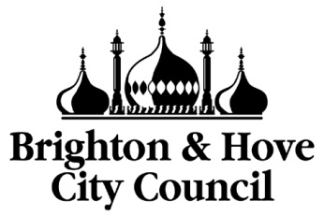
Brighton & Hove City Council
Guide to booking training on the Learning Gateway

To book on any training courses you need to book onto them through the BHCC Learning Gateway which can be found here: https://learning.brighton-hove.gov.uk/cpd/portal.asp. The home page looks like this:

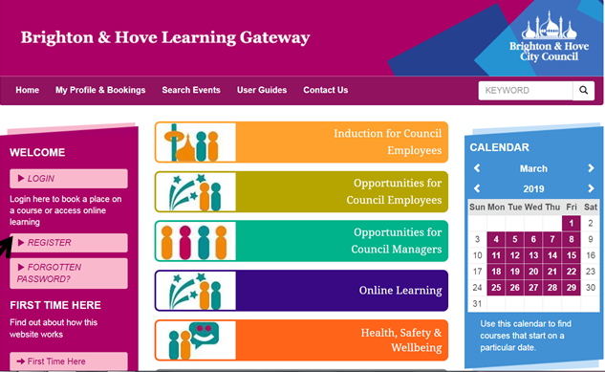
1. First of all check whether the pharmacy is already registered on the Learning Gateway. To do that first click on Register. | See above.
2. Click on the drop down menu and select the Statutory partner organisation employees / volunteers… option | 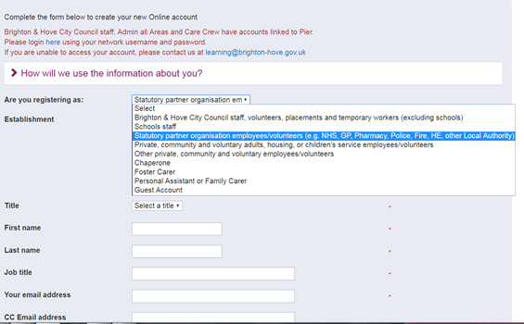
3. From the next drop down menu select Healthcare/GP/Pharmacy | 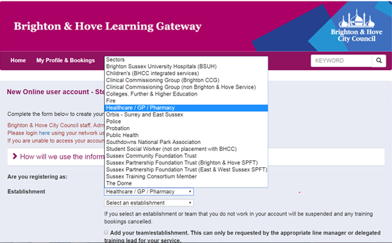
4. Click on the select establishment drop down menu to see if your pharmacy is there. Many pharmacies are already registered on the portal. If yours is in the drop down list then it has already been registered. Then go back to the home page and log in. If you do not know who is the named person at the pharmacy who set it up and has the login details or if you have the log in but not the password, contact:  learning@brighton-hove.gov.uk for assistance | 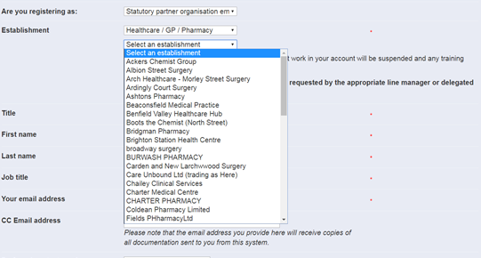
5. If the pharmacy is not registered then you will need to register it by clicking on the Register button to sign up the pharmacy. The first person to register the pharmacy will have managerial rites and be able to book others under the pharmacy onto training courses, once it has been set up.

Once your pharmacy is registered people can then register against that pharmacy or alternatively, the person with manager rites can sign them up for training

6. Repeat steps 1 – 3. Complete an account request form to request an account by clicking on Register on the home page. Click on the drop down menu and select the Statutory partner organisation employees / volunteers… option

4. From the next drop down menu select Healthcare/GP/Pharmacy | 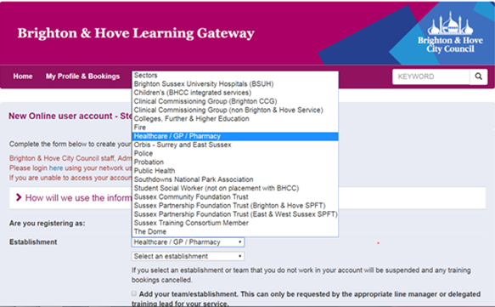
5. A set of fields will then appear which you need to complete. Once done click on the submit button.
6. Once the application has been approved by the Council you can then book onto courses
7. To book any courses you need to log in to the gateway
8. You can browse courses under the different headings, you will probably only need to use the Health Promotion courses tab. You can also find courses using key words in the search box. | 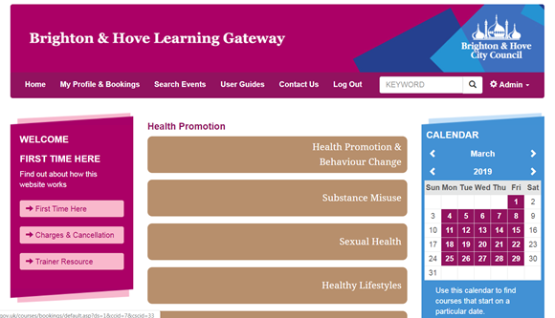
9. Alternatively, if you know the date of the training you can click on the calendar on the right of the page and it will list the courses on that date.
10. Once you have found the course you are interested in, you can click on the blue button on the right that says full details for further information. | 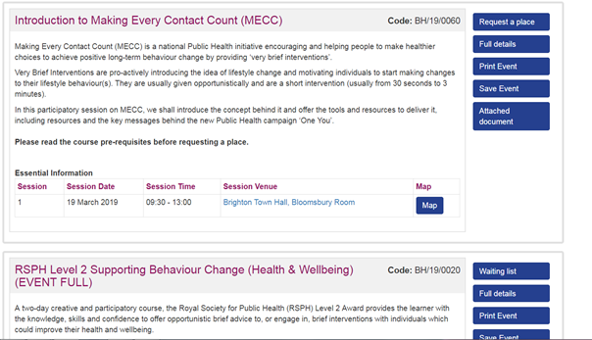
11. If you are happy that this is the course you want to book on to, click on the blue button that says request a place. If it is already fully booked you will be given the option to get onto the waiting list.
12. A confirmation email will be sent to you in due course once your place has been approved.

Appendix 3 – Stop Smoking Consultation Stages
Stage | Intervention Type | Service Specification - Outcome
Initial assessment  discussion of quitting options (NRT)  And Set  Quit Date (discussed with individual) | Face to Face  Approx. 20 mins  Payment: £25 | - Identify readiness to quit and commitment to participate in Stop smoking programme  - Describe typical treatment programme, aims, length of treatment and options, side-effects, effects of passive smoking and benefits of quitting (stopping)  - Discuss tobacco withdrawal syndrome, common barriers to quit, appropriate NRT treatment Varenicline, e cigs and support strategies  - Take an initial carbon monoxide (CO) reading.  Set a 4 week quit date –  - Set a quit date – can agree to start this from the day commencing after this initial appointment (if the individual has already commenced a quit attempt within the last 72 hours, then book in a follow-up appointment for 2 later)  - Plan for the week ahead – any social occasions?  - Agree treatment plan – if NRT dispensed it must be provided to the individual at this appointment  - Complete the relevant sections of the template  - Prompt commitment to quit by booking in a face-to-face meeting or phone call for follow up 2 weeks after quit date  - Set a quit date (4 weeks from now) and inform individual to attend an appointment for CO verification on that date  - Complete the Pharmoutcomes template  Refer individuals over 35 years old presenting with the following: Chronic Obstructive Pulmonary Disease (COPD) risk factors to their GP  - Exceptional breathlessness  - Chronic cough  - Regular sputum production  - Wheeze  - Risk factors for lung cancer  - Coughing blood  - Unexpected weight loss  - Constant chest or shoulder pain  - Cough lasting for more than 3 weeks
Second appointment - Support following Quit Day | Face-to-face or Telephone call (provided 2 weeks after the quit date)  Approx. 10-15 mins  Payment £5 | - Reminder of coping mechanisms  - Repeat NRT required? (not if 4 weeks of products have already been dispensed at the initial appointment)  - Keep motivated  - CO reading (if face-to-face appointment)
Support following Quit Day | Face-to-face or Telephone call  Approx. 10 mins  Optional: Payment £5 | - Repeat NRT required? ( not if 4 weeks of products have already been dispensed at the initial appointment)  - Keep motivated  - If relapsed during the 4 week quit still provide support and maintain quit date appointment  - CO reading (if face-to-face appointment)
Four week follow up and Final Carbon Monoxide (CO) reading  i.e. 4 weeks after Quit Day | Face-to-face for CO verified  Approx. 15 – 20 mins  CO-verified payment £70  Telephone call for non-CO verified Individual Self-  reported quit Payment £20 | - Best practice is to take CO validation reading  CO verification must be taken for £70.00 payment to be made at 4 Weeks  - Individual advised to notify GP of quit attempt to update records  - Encourage total abstinence onwards from quit date  - Inform individual of further online quit support resources available on BHCC website here or via Smokefree website here  £20 for non-CO verified self-reported 4-week quit*  * A Self-reported smoker is one who reports not smoking for at least 15–28 days of a 4 week attempt. Please see Appendix 4 and appendix 7 for guidance on the questions required to ask individuals via the telephone conversation in order to make a claim

Appendix 4

Service Descriptions

CO Verified Quit: A CO-verified four-week quit = A treated smoker who reports not smoking for at least days 15–28 of a quit attempt and whose CO reading is assessed 28 days from their quit date (-3 or +14 days) and is less than 10 ppm. This is lower for women who are pregnant at 4 ppm or less. The -3 or +14 day rule allows for cases where it is impossible to carry out a face-to-face follow-up at the normal four-week point (although in most cases it is expected that follow-up will be carried out at four weeks from the quit date). This means that follow-up must occur 25 to 42 days from the quit date (Russell Standard).

Self –reported Quit = A treated smoker who reports not smoking for at least days 15–28 of a quit attempt and not relapsed within the last 72hrs and is offered a follow-up appointment with the opportunity to complete a CO verification at 3 months.

Appendix 5

Guidance on E-Cigarette

In England, e-cigarettes are the most popular stop smoking aid for adults and based on the evidence to date are considered 95% less harmful than cigarettes and this has contributed to the decline in tobacco smoking nationally. Combined with behavioural support from stop smoking advisors, quit success rates can be greatly improved.
Latest research from PHE (2015) states that although not completely risk free, e-cigarette use is significantly less harmful than tobacco smoking and as such, PHE recommends that services should offer e-cig friendly support to people who are using Electronic Nicotine Delivery Devices (ENDS) in a quit attempt. Optional online training on E-cigarettes can be accessed via the NCSCT online training page.

Many users of e-cigarettes continue using the product both before and after quitting smoking, and for a longer period after quitting than most NRT users. It is advisable to suggest to individuals wanting to use E-cigs, to access further guidance on which type of devices are best suited for them and their quit (Generation 1, 2 and 3 for Tank models). All devices can be used with NRT and nicotine delivery from E-cigarettes is capped at 20mg under the Tobacco Product Directive (TPD).

A current list of local Independent British Vape Trade Association (IBVTA) registered Vape can be found online at https://www.findavapeshop.com/find-a-shop/. These are reputable sellers following national TPD and trading standard regulations and ensure no association or funding from big tobacco companies (PMI / BAT).

Appendix 6

National Guidance

NICE NG92: Stop smoking interventions and services March 2018
PH14: Young people services (2014 update)
Russell Standard http://www.ncsct.co.uk/publication_The-Russell-Standard.php
Under 18s guide to quitting smoking - http://www.nhs.uk/Livewell/smoking/Pages/Teensmokersquit.aspx
Tobacco control plan for England 2022
National Institute for Health & Care Excellence Guidance (NICE) guidelines
NCSCT – Service delivery guidance, individual stop smoking intervention delivery and extra Training support.
NICE – Nicotine: https://bnf.nice.org.uk/drug/nicotine.html

Appendix 7

Self-reported 4 week quit – Assurance questions prior to claiming:
Questions to ask individuals self-reporting a 4 week quit via the telephone: | Reasonable responses:
How do you feel about the support you have received during your 4 week quit? | Positive - Discuss with individual to receive feedback on service.  Negative - provide them with the opportunity to attend another appointment or refer on to other services for support
Have you managed to remain without tobacco for at least 15-28 days of your 4 week quit attempt? | Yes - I have not smoked for 15-28 days of my 4 week quit (follow on to next question)  No – Use professional discretion to offer them to start their quit journey again and set-up initial appointment
Are you confident that you could continue to remain quit without further support? | Yes – Next question  No – Offer another appointment to start quit attempt again or refer into health trainer service for extra advice and support
Would you like to be referred for further support into the Health trainer service? | Yes – make a referral to service  No – provide recognition for quit and motivation to continue. Remind the individual that they can come back for further information if required or direct to the health trainer service online or by telephone
Appendix 8
Service User Survey

We are very keen to improve the Stop Smoking Service provided in Brighton and Hove. Your views about this are very important to us and will be treated in the strictest confidence. Please answer the following questions as honestly as you can. The results of this survey will be used for evaluation and to improve services for the future.

Please tick your answer for each question.
1 | Overall how satisfied are you with the stop smoking service you received? | Unsatisfied | Unsure Please comment | Satisfied
2 | Would you recommend this service to others who want to stop smoking? | No | Unsure - Please comment | Yes
3 | If you started smoking again would you return to the service for help to stop? | No | Unsure - Please comment | Yes
6 | How satisfied were you with the amount of time you had to wait for your first appointment with the Service? | Too long please specify | Unsure - Please comment | Satisfied please specify
7 | How helpful was the advisor support? | Unhelpful | Unsure - Please comment | Helpful
11 | Were you offered a range of Nicotine replacement therapy -medication? | No | Unsure - Please comment | Yes
12 | Was it easy to obtain your Nicotine replacement therapy -medication? | No | Unsure - Please comment | Yes
13 | If you have any suggestions as to how we can improve our Stop Smoking Service please give details here:

Thank you for your time in completing this survey. Please return it to your stop smoking advisor or in the envelope provided.

Appendix 9

The Community Pharmacy Domiciliary Stop Smoking Service

1. Aims of the Domiciliary Stop Smoking (DSS) Service

- The DSS service builds on the Community Pharmacy Stop Smoking Service Specification utilising the service delivery framework to provide a home-based service.
- Stop Smoking Advisors will offer a home-based stop smoking service for individuals with Chronic Obstructive Pulmonary Disease (COPD) and other long term conditions.
- The DSS service will provide one to one behaviour support along with the supply of stop smoking pharmacotherapy to individuals within their own homes.
- The DSS will improve access to stop smoking services through the development of a citywide domiciliary service that mirrors the population coverage of the six Brighton and Hove GP clusters (see page 3) including prevalent locations to ensure equitable access to home based services.

2. Service Outline

Contractors providing the DSS must adhere to the criteria in the Community Pharmacy Stop Smoking Service Specification. The community pharmacy stop smoking delivery model is detailed in Appendix 3 .The same process and consultation format should be used for individuals using the domiciliary service. Individuals requiring the service are eligible for up to three visits during the stop smoking support cycle.

3. Service Standards

- Contractors offering the DSS must meet all the requirements of the Community Pharmacy Stop Smoking Service Specification.
- Contractors must ensure there are no exclusions to the DSS service before visiting an individual.
- Lone working and risk assessment policies must be in place to safeguard and protect SSAs providing the domiciliary service.
- Contractors must ensure SSAs are fully enabled to raise safeguarding issues with their line manager, and where appropriate support these members of staff to raise safeguarding concerns with the local authority(refer to Section 7)
- Contractors must ensure that all SSAs providing the domiciliary service have completed a successful enhanced DBS check.
- Contractors must have adequate business insurance to cover provision of the DSS.
- Details of individuals engaging with the Domiciliary Stop Smoking service must be recorded on the PharmOutcomes registration and supply templates. Remuneration will be based on the data entered into PharmOutcomes. The data must be stored in line with General Data Protection Regulations (GDPR).
- Contractors must adhere to GDPR by providing a NHS email account for communication with hospital and community services and for sharing individuals’ information.
- Contractors are required to contact individuals before initiating the service. The initial conversation should include discussions around the visit risk assessment, current medical history and medications and information about previous stop smoking attempts. Contractors should ensure the initial screening conversation covers all the requirements of their lone working and risk assessment policies
- To undertake the domiciliary service the stop smoking advisor will need access to a home visit kit bag. For guidance on the suggested contents of the kit bag to be included within the kit bag please see Appendix 10.
- The SSA must ask the individual engaging with the DSS to complete a patient satisfaction questionnaire (Service User Survey Appendix 8) at the second or third visit in the stop smoking support cycle.
- The contractor must comply with the BHCC auditing procedures for locally commissioned services as defined in the service contract.

4. Referral Pathways

Individuals requiring smoking cessation support in their own homes can be referred to the community pharmacy of their choice by sending a referral email to the community pharmacy NHS email address or by contacting the pharmacy by telephone. A list of DSS providers will be made available on Brighton and Hove City Council (BHCC) website

Individuals will be referred from the following healthcare settings:

Hospital

Hospital patients will receive an initial stop smoking assessment by the Hospital Smoking Cessation Service Lead (HSCSL). Patients identified to be housebound will be referred by the HSCSL to the commissioned community pharmacy of their choice commissioned to provide the DSS service.

Community

Individuals in the community identified by the Community Respiratory Service (CRS) as requiring stop smoking support can be directly referred to the community pharmacy of the individual’s choice using the NHS email address or by phone. Adult Social Care services and other community providers can also signpost to community pharmacies offering the DSS service. A list of Community Pharmacy DSS providers will be available on the BHCC website

GP Practices

GP practices can refer individuals to community pharmacies by sending an email to the community pharmacy NHS email address or by phone. Brighton and Hove GP practices will be provided with a list of DSS providers and sign posted to the BHCC website. It is the responsibility of the community pharmacy to engage with local GP practice to raise awareness of the DSS service and how to refer into it.

Community Pharmacies

Community pharmacies NOT offering the DSS service can signpost individuals to community pharmacies commissioned to provide the service. Information detailing Community Pharmacy DSS providers will be available on the BHCC website

4. Payment Schedule

- The payment schedule and claim procedure for the delivery of the SS aspect of the domiciliary service is defined in the Community Pharmacy Stop Smoking Service Specification section 8.
- The domiciliary service requirements of the SS service will be remunerated at £25 per visit. The remuneration takes into account the costs associated with setting up a domiciliary service such as training, enhanced DBS checks, risk assessment and lone working policies. The remuneration also includes the costs associated with travel, parking, insurance and mobile phones. A maximum of three visits can be claimed per individual for each stop smoking support cycle.

5. Termination and Change Arrangements

- The DSS service specification runs for the period from 1st April 2021 to 31st March 2023. Including a review of the service in April 2020.
- Termination can be made earlier by either party at 3 month written notice or on failure to provide activity data or meet the terms and conditions of the service specification as stated above.
- Pharmacies must inform the commissioner within 72 hours if for any reason they are unable to provide the service either temporarily or permanently.

Appendix 10

Domiciliary Stop Smoking Service
Kit Bag- recommended contents

- Appointment diary and appointment cards
- Charged mobile phone and personal alarm
- Photo ID
- Hand gel
- Paperwork file containing, risk assessment forms, initial referral information, consultation record form, levy declaration form and health promotion leaflets to support behaviour change.
- CO monitor and mouth pieces
- Nicotine Replacement Therapy

Introductory Phone Call Guidance

- Discuss the visit risk assessment/ lone worker policy criteria with individuals before arranging a visit
- Discuss the format of the 12 week programme and the number of home visits available
- Discuss relevant medical conditions and medications being taken by the individual
- To decide on the NRT to include in the kit bag discuss options with the patient i.e. gather information about how many cigarettes smoked per day, when they have their first cigarette, have they tried any NRT and formulation preferences.
- Discuss payment criteria. If an individual pays for NHS prescriptions ensure they are aware that the NHS levy (per formulation) will be collected when the NRT is supplied and to ensure change is available.

Appendix 11

The Community Pharmacy Young Persons (aged 12-15 years) Stop Smoking Service (YPSS)

1. The Aims of the Service

- The YPSS service builds on the Community Pharmacy Stop Smoking Service Specification utilising the service delivery framework to provide an accessible service to young people between the ages of 12 to 15 years old.
- Young people wishing to access the service will be referred from the Schools Stop Smoking Lead (SSSL) or the School Nurse Service to the community pharmacy of their choice commissioned to provide the service.
- The service will be provided by SSAs using a young person friendly and non-judgemental approach. The contractor will ensure that all staff involved in the provision of the service maintain individual confidentiality, and are appropriately trained in the operation of the service, including sensitive, person centred communication skills.

2. Background

In the UK more than 207,000 children aged 11-15 start smoking each year. Smoking just one cigarette in early childhood doubles the chance of a teenager becoming a regular smoker by the age of 17. The earlier the young person becomes addicted and continues smoking into adulthood the greater the risk of developing heart and lung disease later in life. In 2014, 77% of smokers aged 16 to 24 said they began smoking before the age of 18.2.

According to the national What about Youth survey Brighton and Hove has the highest rate of current 15 year old smokers with a prevalence rate of 14.9%, Compared to the south East at 9% and the English National average at 8.2% (NHS Digital, 2015)

NICE guidance supports smoking cessation in young people through local smoking cessation services giving access to behavioural support and pharmacotherapy. Smoking cessation services in Brighton & Hove for under 16 year old residents is currently limited to GPs and the Schools Stop Smoking cessation Lead. This service
specification improves options for young people by providing stop smoking services in the community pharmacy setting. For further information regarding the risks associate with childhood smoking please see Appendix 12.

4. Service Standards

- Contractors offering the YPSS must meet all the requirements of the Community Pharmacy Stop Smoking Service Specification.
- Contractors must ensure that all SSAs providing the YPSS service have completed a successful enhanced DBS check. See section 7 of the Community Pharmacy Stop Smoking Service Specification.
- Service delivery must be in accordance with the BHCC accredited training standards for the Stop Smoking service detailed in section 5 of the Community Pharmacy Stop Smoking Service Specification. In addition the CPPE e-learning training module Safeguarding children and vulnerable adults: Level 1 (2019) must also be completed. The contractor must ensure that at least one SSA is trained to provide the YPSS service
- Pharmacotherapy should be supplied in accordance with section 9 of the Community Pharmacy Stop Smoking Service Specification. Please note Varenicline is not licenced for use in young people under the age of 18 years and young people under the age of 16 are exempt from the NHS prescription levy.
- SSAs must use the Gillick Competency checklist (Appendix 13) to assess a young person under 16 years of age to ensure they fully understand the stop smoking programme. The Gillick Competency checklist should be completed on Pharmoutcomes during or after the consultation.
- Contractors must ensure SSAs are fully enabled to raise safeguarding issues with their line manager, and where appropriate support these members of staff to raise safeguarding concerns with the local authority(refer to Section 7 of the Community Pharmacy Stop Smoking Service Specification)
- The SSSL will be notified of contractors signing up to provide the service for referral purposes. Young people not meeting the inclusion criteria of the service should be referred back to the SSSL.
- Contractors should aim for at least 85% of all young people using this service to have a validated quit at 4 weeks with an expired breathe into a carbon monoxide monitor that is less than 10 parts per million.
- The contractor will ensure that pharmacists and counter staff involved in the provision of the service have up to date knowledge, maintain patient confidentiality, offer a user-friendly and non-judgemental service and are appropriately trained in the operation of the service, including sensitive, person centred communication skills
- Details of individuals engaging with the YPSS service must be recorded on the PharmOutcomes registration and supply templates. Remuneration will be based on the data entered into PharmOutcomes. The data must be stored in line with General Data Protection Regulations (GDPR).
- The SSA must ask the individual engaging with the YPSS service to complete a patient satisfaction questionnaire (Service User Survey Appendix 8) at the CO verified 4 week quit consultation.
- The contractor must comply with the BHCC auditing procedures for locally commissioned services as defined in the service contract.

4. Payment Schedule

- The payment schedule and claim procedure for the delivery of the YPSS is defined in the Community Pharmacy Stop Smoking Service Specification section 8. Please Note: The 4 week quit payment for the YPSS service is enhanced and will be paid at £90 for a CO verified 4 week quit.
- The enhanced DBS check will be remunerated by BHCC for one Stop Smoking Advisor per contractor per year, additional costs related to the enhanced DBS check must be incurred by the provider or as negotiated with the commissioner on an individual basis.
- The additional safeguarding training required to provide the young people’s service will not be remunerated; however costs are reflected in the 4-week quit enhanced payment.

5. Termination and Change Arrangements

- The YPSS service specification runs for the period from 1st April 2019 to 31st March 2021. Including a review of the service in April 2020.
- Termination can be made earlier by either party at 3 month written notice or on failure to provide activity data or meet the terms and conditions of the service specification as stated above.
- Pharmacies must inform the commissioner within 72 hours if for any reason they are unable to provide the service either temporarily or permanently.

Appendix 12

Background information: Childhood Smoking
In the UK more than 207,000 children aged 11-15 start smoking each year. Smoking just one cigarette in early childhood doubles the chance of a teenager becoming a regular smoker by the age of 17. The earlier the young person becomes addicted and continues smoking into adulthood the greater the risk of developing heart and lung disease later in life. In 2014, 77% of smokers aged 16 to 24 said they began smoking before the age of 18.2.

Living with adults or siblings who smoke also makes it much more likely that a young person will start and continue smoking. Other factors that influence and contribute to smoking uptake in this age group include, smoking by friends and peer group members, the ease with which young people can obtain cigarettes, exposure to tobacco marketing, and depictions of smoking in films, television and other media.
Young people who smoke are more susceptible to coughs, wheeziness and shortness of breath. This has a direct effect upon school attendance and education due to school absence.

The harms from smoking begin for many children at birth19. Exposure to second-hand smoke during pregnancy increases the risk of miscarriage, premature birth, still birth and low birth-weight. The early exposure to second-hand smoke in the womb also increases the risk of infant mortality, wheezy illnesses and psychological problems such as attention and hyperactivity problems after birth.

Many children are also born into households that smoke with more than two thirds of children reporting high exposure to second-hand smoke from within their own homes or in other people’s homes. This early exposure to second-hand smoke contributes to many adverse health outcomes including lower respiratory tract infections, asthma, wheezing, middle ear infections and invasive meningococcal disease. There is also evidence linking exposure to second-hand smoke with impaired mental health and with increased school absenteeism.

Ambitions set by the Department of Health, in the tobacco control plan, ‘towards a smoke-free generation: a tobacco control plan for England’ have a specific smoking-related outcome to achieve for young people. That is to reduce the number of 15 year olds who regularly smoke from 8% to 3% or less by 2022.

Local Context
According to the national What about Youth survey Brighton and Hove has the highest rate of current 15 year old smokers with a prevalence rate of 14.9%, Compared to the south East at 9% and the English National average at 8.2% (NHS Digital, 2015).
Older students are more likely to smoke with 95% of 11-12 year old students saying they have never smoked. This falls to 49% for 15-16 year old students (Brighton & Hove City Council, 2015).

For pupils aged 11-14, there is not much difference between girls and boys who have tried smoking (girls 13%, boys 12%). However this changes with age and for pupils aged 14-16, girls are more likely to have smoked (49%) compared to boys (39%). Also for pupils aged 14-16, girls are more likely to be regular smokers (12%) compared to boys (7%) (Brighton & Hove City Council, 2015).

Appendix 13

Young people Service – Gillick Competency.

Adolescents over 16 years of age are presumed to have sufficient capacity to decide on their own medical treatment, unless there is sufficient evidence to suggest otherwise.
Young people under 16 years of age who wish to receive health care and stop smoking services can do so without the consent of a parent/carer. However, the young person needs to be assessed as ‘Gillick Competent’, that is, ensure they fully understand the treatment they will be involved in.
Gillick competency can be assessed by completing the checklist below. The checklist is available to complete on PharmOutcomes.

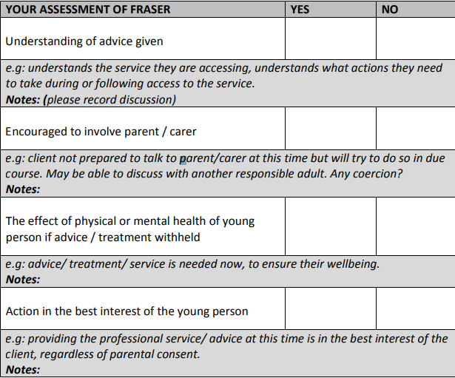

Appendix 14

Nicotine Replacement Therapy (NRT) e-Voucher Scheme

The aim of the NRT e-voucher scheme is to enable individuals to easily access NRT when attending a stop smoking programme provided by the BHCC Health Trainer team and other authorised Stop Smoking Advisors (SSAs). The NRT e-voucher scheme is a mandatory requirement of providing the Community Pharmacy Stop Smoking Service.

NRT products are classified as General Sales List products; they can therefore be supplied directly from community pharmacies without a prescription. This enables individuals to access stop smoking pharmacotherapy at the same cost as the NHS prescription levy, or free if the individual is exempt from NHS prescription charges, instead of the recommended retail price.

Under the scheme, a trained stop smoking advisor (Health Trainers or Sussex Community Partnership Staff) recommends the supply of NRT products using an e-voucher that is issued to a pharmacy participating under the scheme of the individual’s choice. The NRT e-voucher request is generated on PharmOutcomes by a Health Trainer (or other authorised SSA) who assesses suitability of individuals attending the local stop smoking service for stop smoking pharmacotherapy. Please note that this scheme does NOT apply to varenicline (Champix) & buproprion (Zyban) – both are Prescription Only Medicines (POMs).

The authorisation is granted by the Public Health Tobacco Control and Healthy Lifestyles Manager. Please note that SSA’s do not have to be from a clinical background but must have received the 2 day level two training from BSUH lead and be NCSCT certified in order to recommend NRT supply under this protocol and keep their knowledge and skills up to date.

Advisors should keep up to date with their knowledge on medications. This can be done by searching the latest summary of products and characteristics (SPC) of each individual NRT all of which are available on the NCSCT website and guidance from the National Institute for Health and social care excellence
The NRT e-voucher request is then sent to the pharmacy (selected by the individual requiring treatment) via PharmOutcomes. SSAs at pharmacies commissioned to provide the Community Pharmacy Stop Smoking Service receive and process the request on the PharmOutcomes template.

The amount of NRT per voucher:
- A maximum of two product items can be recommended on one voucher for up to 4 weeks
- No more than 1 NRT product per week should be dispensed once individual has reached a 4-week quit.
- No more than 2 weeks supply at a time should be dispensed for an individual receiving 8-12 week follow-up support post the 4 week quit date (and single NRT products only)
- Following the four week post quit date the total prescribed should not exceed 4-6 weeks (dependent on agreed follow-up treatment plan).

Please see the guide for using the NRT e-voucher supply in PharmOutcomes for pharmacy available on the PharmOutcomes template and as a supplement to this specification from the Public Health team.

NRT Supply and Remuneration

- Individuals will be advised by Health Trainers that they must collect their NRT products from the nominated pharmacy within seven days of issue of the NRT e-voucher. Attempts to redeem after 7 days should be referred back to the Health Trainer team for approval (see contact details below)
- A maximum of two NRT products can be recommended on one e-voucher. Individuals will pay a NHS prescription charge for each product supplied. If applicable the stop smoking advisor issuing the NRT must ascertain from the individual if they are exempt from prescriptions charges and note the reason for exemption in PharmOutcomes.
- A professional fee (claimed through PharmOutcomes) of £1.25 will be paid to contractors for each voucher presented
- PharmOutcomes links to the NHS dictionary of medicines and devices and therefore NRT supplied will be remunerated at the listed price.

Contact details

Health Trainer Team
Telephone - 01273 294 589

PHE Fingertips, Local Tobacco control Profiles, Annual Population Survey 2017.
Department of Health and Social Care, Tobacco Contorol delivery Plan 2017- 2022. https://assets.publishing.service.gov.uk/government/uploads/system/uploads/attachment_data/file/714365/tobacco-control-delivery-plan-2017-to-2022.pdf
NICE – Nicotine : https://bnf.nice.org.uk/drug/nicotine.html
Independent British Vape Trade Association, 2019. https://www.findavapeshop.com/find-a-shop/
https://www.brighton-hove.gov.uk/content/health/your-healthy-lifestyle/make-a-healthy-lifestyles-referral
NCSCT E-Learning Modules - http://elearning.ncsct.co.uk/
NSPCC – Gillick Competency and Fraser guidelines – A factsheet 2018’ : https://learning.nspcc.org.uk/media/1541/gillick-competency-factsheet.pdf
Brighton and Hove City council stop smoking services : https://www.brighton-hove.gov.uk/content/health/stop-smoking
Further online support for individuals attempting a 4 week quit :https://www.nhs.uk/smokefre and https://www.brighton-hove.gov.uk/content/health/healthy-lifestyle-one-you/health-trainer
PHE, E-Cigarettes: And Evidence Update, 2015. https://assets.publishing.service.gov.uk/government/uploads/system/uploads/attachment_data/file/733022/Ecigarettes_an_evidence_update_A_report_commissioned_by_Public_Health_England_FINAL.pdf https://assets.publishing.service.gov.uk/government/uploads/system/uploads/attachment_data/file/733022/Ecigarettes_an_evidence_update_A_report_commissioned_by_Public_Health_England_FINAL.pdf
Royal College of Physicians – Nicotine without Smoke: Tobacco harm reduction. http://elearning.ncsct.co.uk/usr/docs/Royal%20College%20of%20Physicians.%20Nicotine%20without%20smoke.%202016.pdf
Action on Smoking and Health, 2015, Young People and Smoking fact sheet, http://ash.org.uk/files/documents/ASH_108.pdf [Accessed 16 August 2016]
BMA Board of Science. Breaking the Cycle of Children’s Exposure to Tobacco Smoke. British Medical Association, London, 2007.
2. Department of Health. Towards A Smokefree Generation: A Tobacco Control Plan for England. 2017.
Current smokers include regular and occasional smokers
Action on Smoking and Health, 2015, Young People and Smoking fact sheet, http://ash.org.uk/files/documents/ASH_108.pdf [Accessed 16 August 2016]
BMA Board of Science. Breaking the Cycle of Children’s Exposure to Tobacco Smoke. British Medical Association, London, 2007.
2. Department of Health. Towards A Smokefree Generation: A Tobacco Control Plan for England. 2017.
Action on Smoking and Health, 2015, Smoking Still Kills, http://www.ash.org.uk/smokingstillkills [accessed 16 August 2016]..
Smoking and Young People, Royal College of Physicians; 1992.
Department of Health Social Care, Tobacco Control Delivery Plan 2017- 2022 : https://assets.publishing.service.gov.uk/government/uploads/system/uploads/attachment_data/file/714365/tobacco-control-delivery-plan-2017-to-2022.pdf
Current smokers include regular and occasional smokers
Stop Smoking Service Delivery and Training - http://www.ncsct.co.uk/
NICE – Nicotine : https://bnf.nice.org.uk/drug/nicotine.html

